Class Number Name

Machine number Experiment date Report date

**Experiment topic:**

Experiment 5 Queries involving JOINS and subquery

1. **Experiment objectives**

1）Master the use of INNER JOIN clauses.

2）Master the methods of using subqueries.

**2. Experimental content**

4.1 Queries involving two or more tables(JOINS)

1) Get a list of project names with the employee numbers of the employees

working on them.

NOTE: pname is from PROJ, eno is from WORKS (could use EMP, but WORKS is

closer to PROJ)

2) Get the names of employees in the 'information' department

NOTE: ename is from EMP, dname (used for selection clause) is from DEPT

dno is the primary/foreign key match between DEPT and EMP

3) Get the names of all projects worked on by the employee named ‘pearse’

NOTE: pname is from PROJ; ename is from EMP; PROJ and EMP join through

WORKS

eno is the primary/foreign key match between EMP and WORKS

pno is the primary/foreign key match between WORKS and PROJ

4) Get a list of employee names with their department names

5) Get a list of employee names with their department names for employees

earning more than £25,000

6) Get a list of project names with the names of all employees

4.2 Subqueries

1) Query 2) (Get the names of employees in the information department) could

be answered using a subquery approach. Try it. (Query 1 cannot use a

subquery).

2) Query 3) could also be specified as a subquery.

3) Get the employees with a lower than average salary

4) How many employees are there in the ‘information’ department (i.e.

dname)?

NOTE: Try this as a single query block join and also as a nested query.

5) Get a list of employee names for projects named ‘payroll’ or ‘database’.

NOTE: Again, try this as a single query block join and also as a nested query.

6) Get the names of all employees with an above average salary.

7) Get the names and salaries of all employees in the ‘information’ department

with salaries above the average for employees in the ‘information’

department.

8) Get the names and salaries of employees in the ‘information’ department

who have a higher salary than the maximum salary in the ‘service’

department

**3. Experiment procedure**

According to the task, list the task description, the screenshot of the solution process and the screenshot of the running result.

3.1 Task description

The task solution and results

4.1 1）

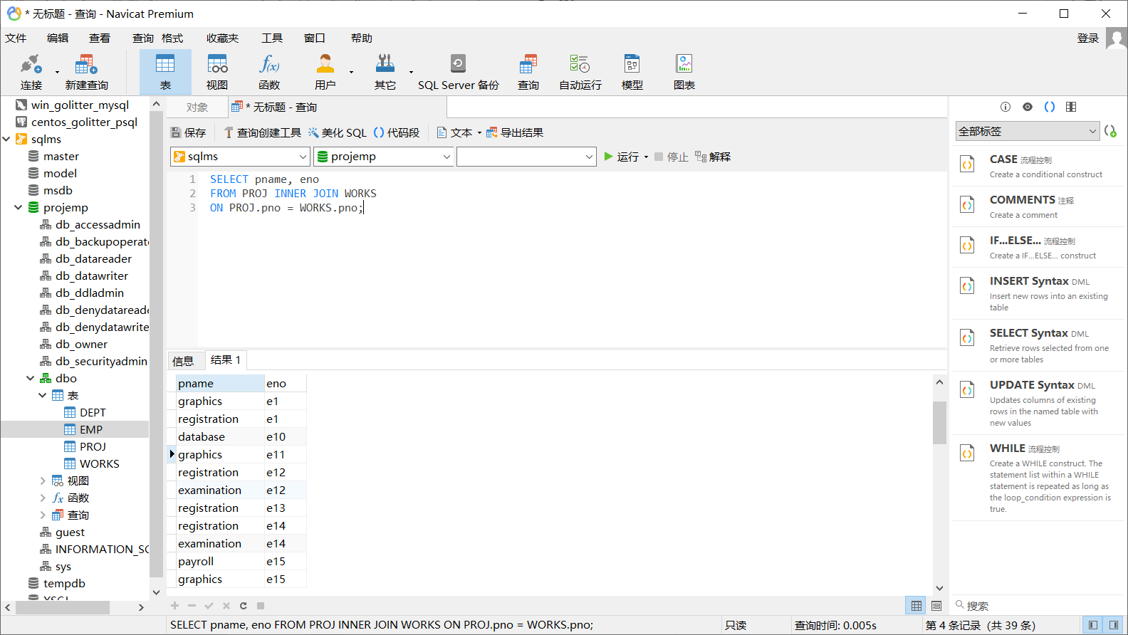

2）

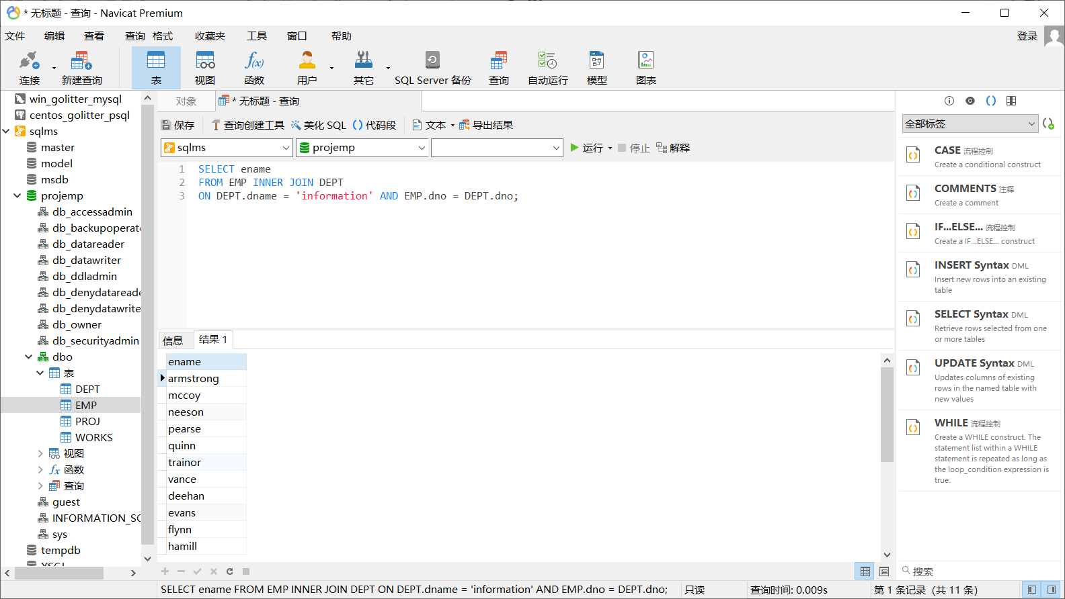

3）

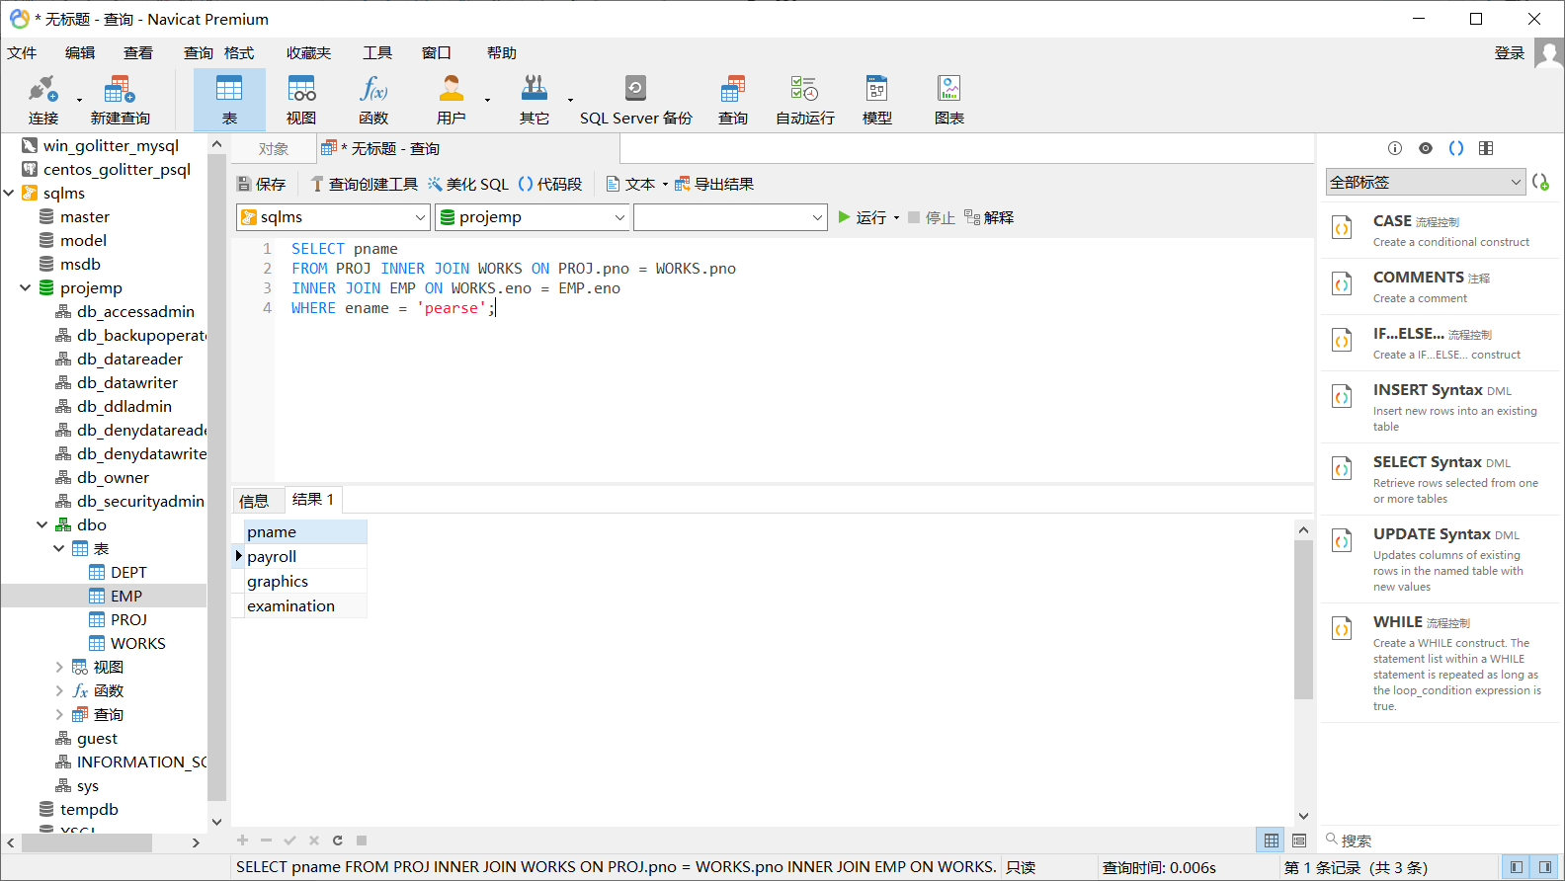

4）

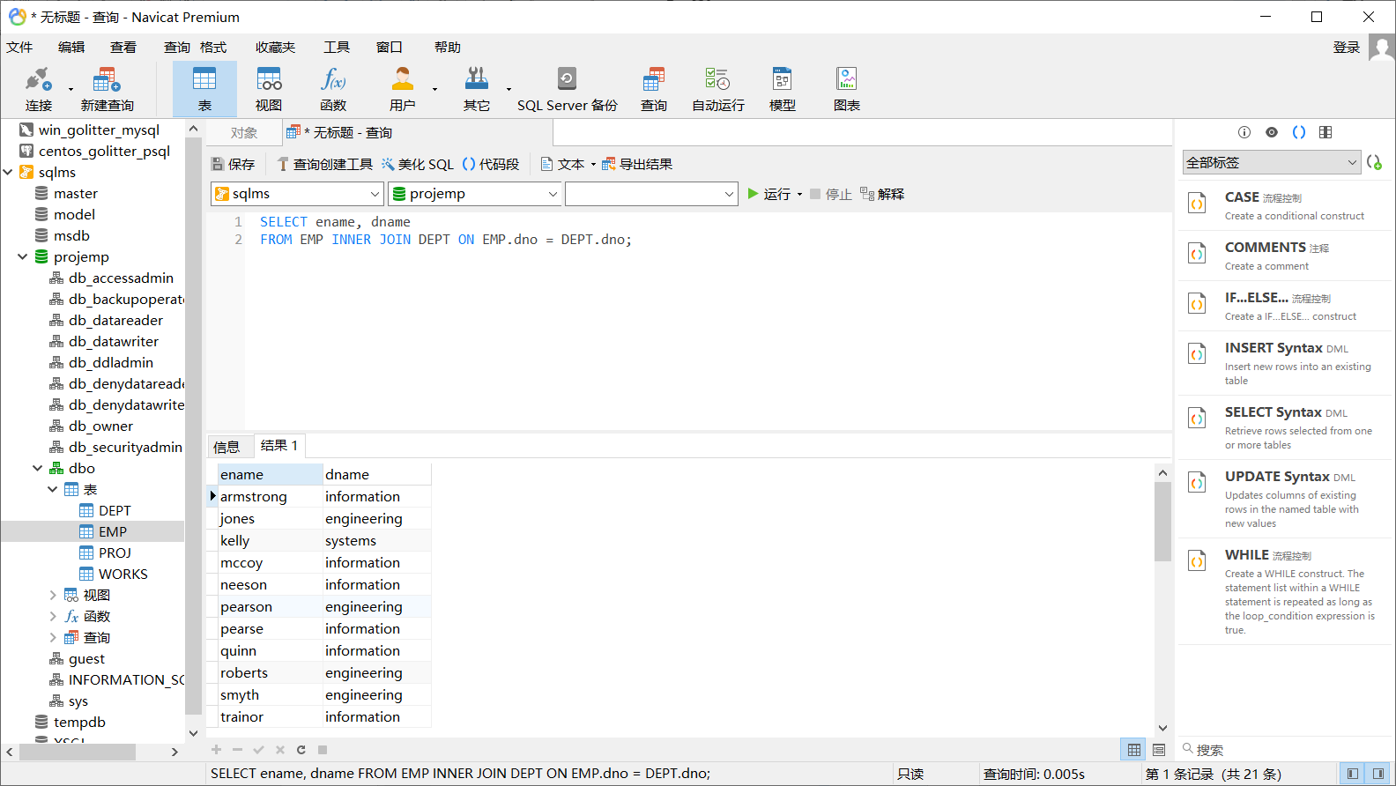

5）

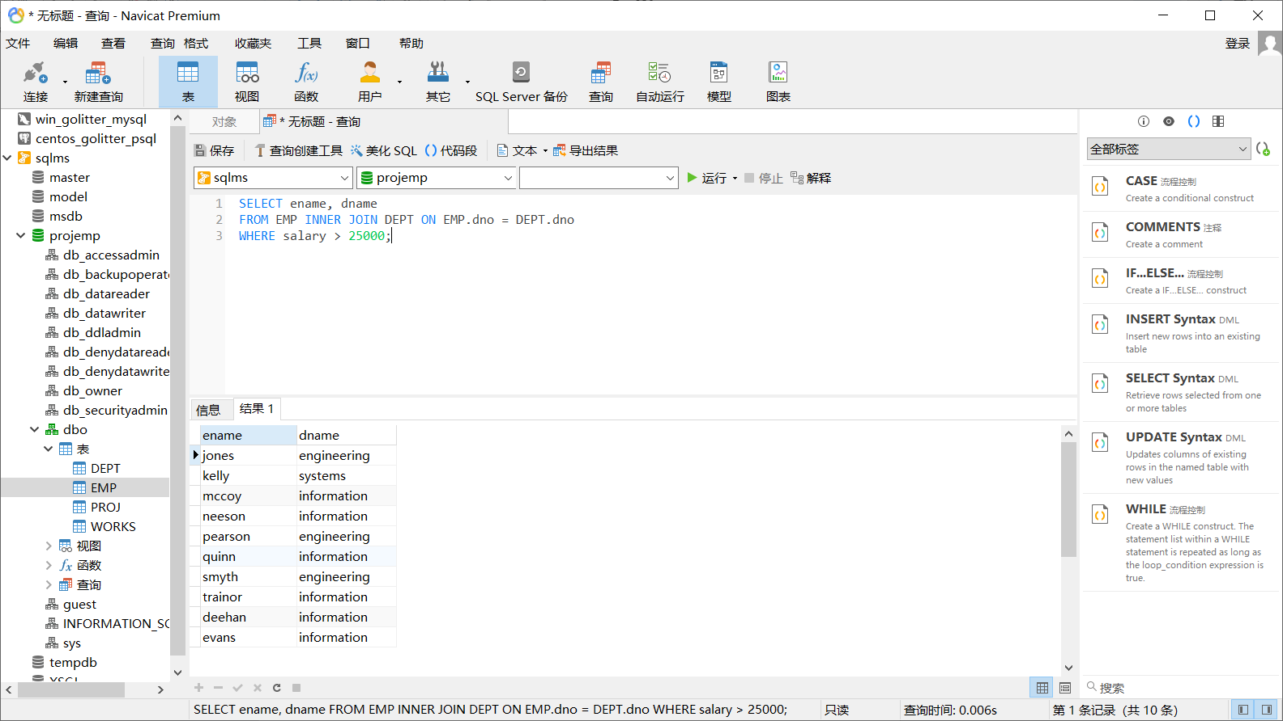

6）

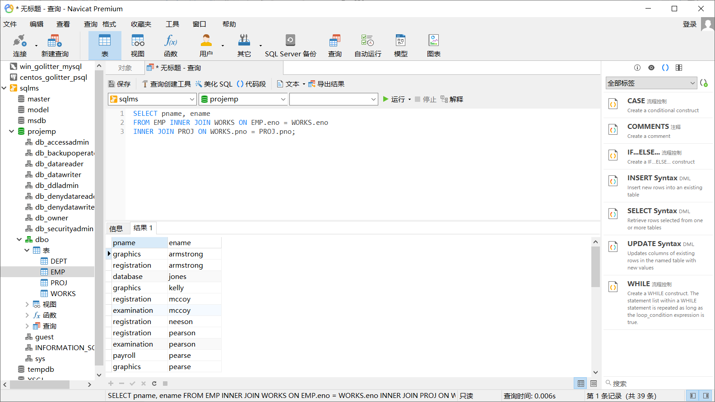

4.2 1）

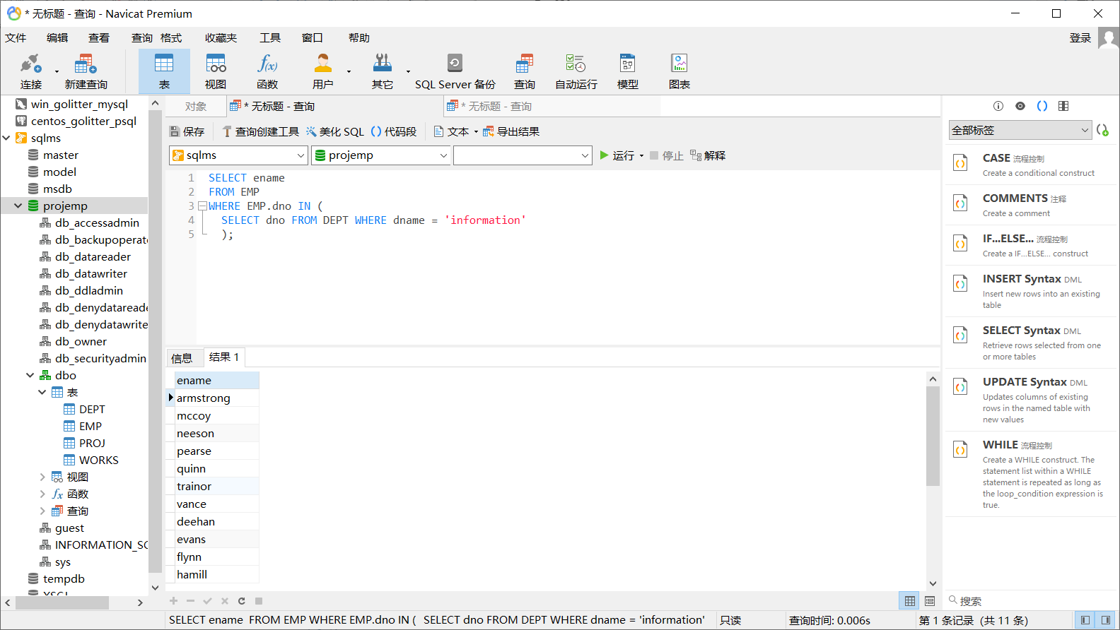

2）

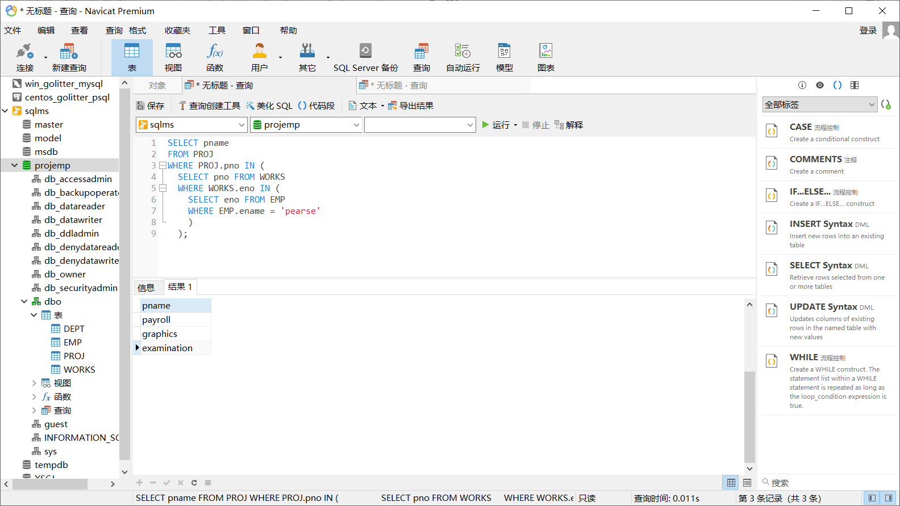

3）

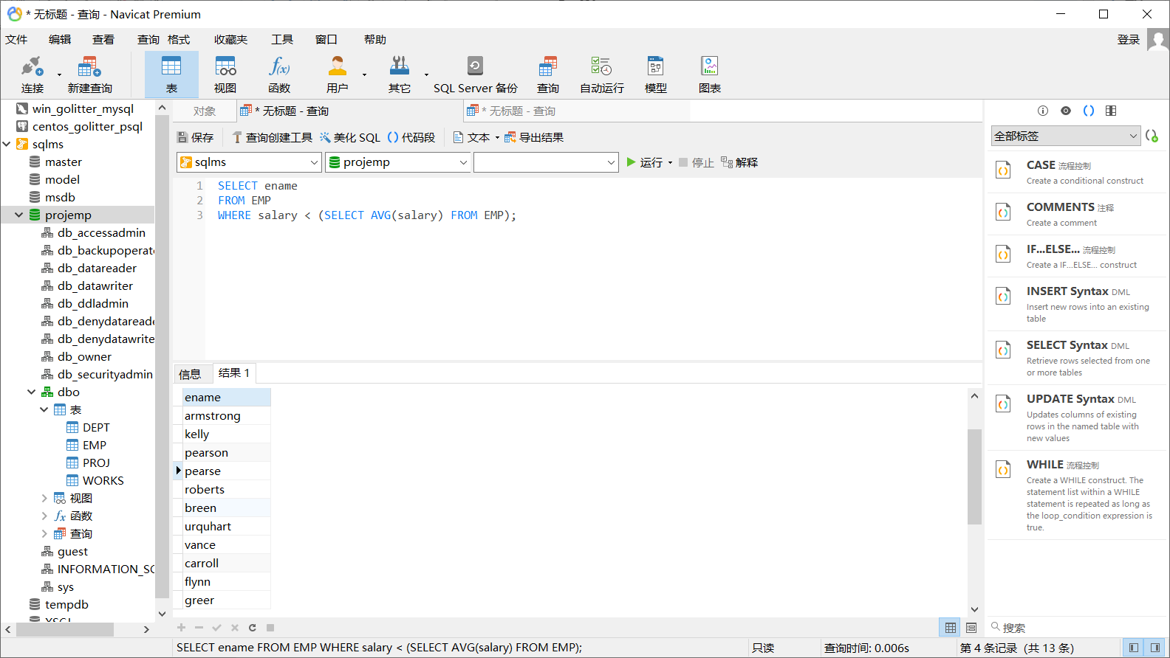

4）

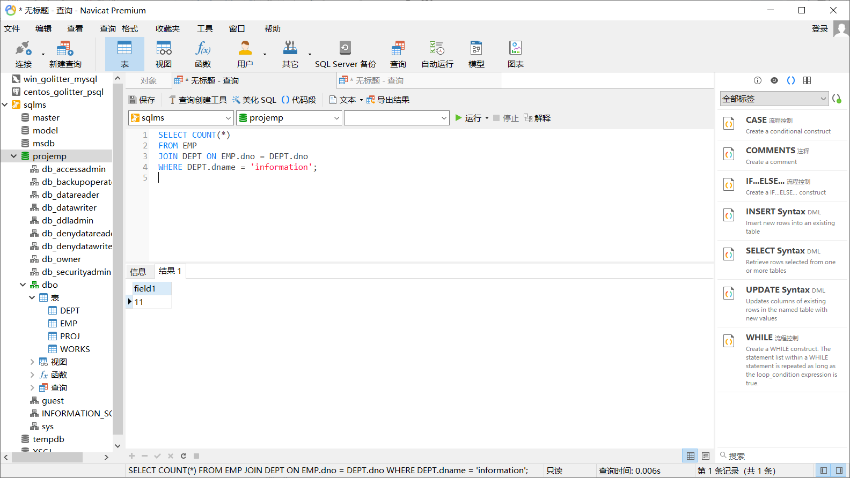

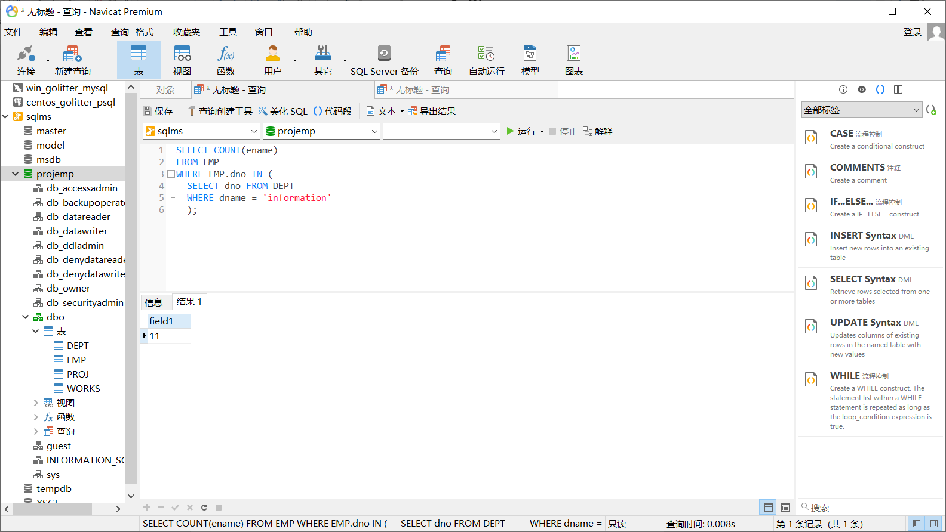

5)

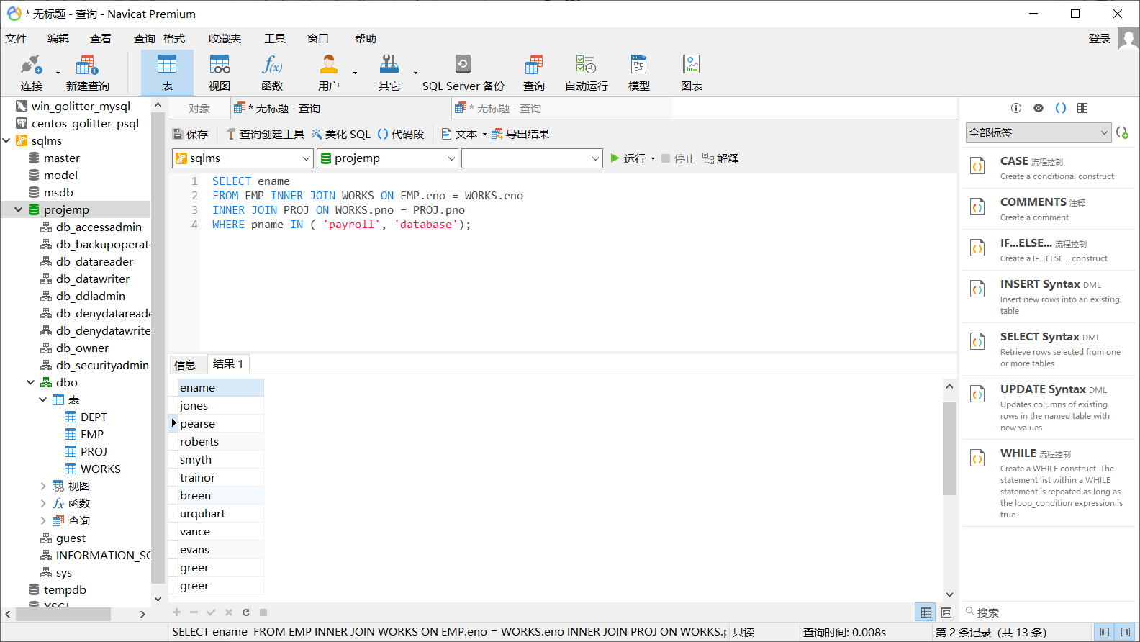

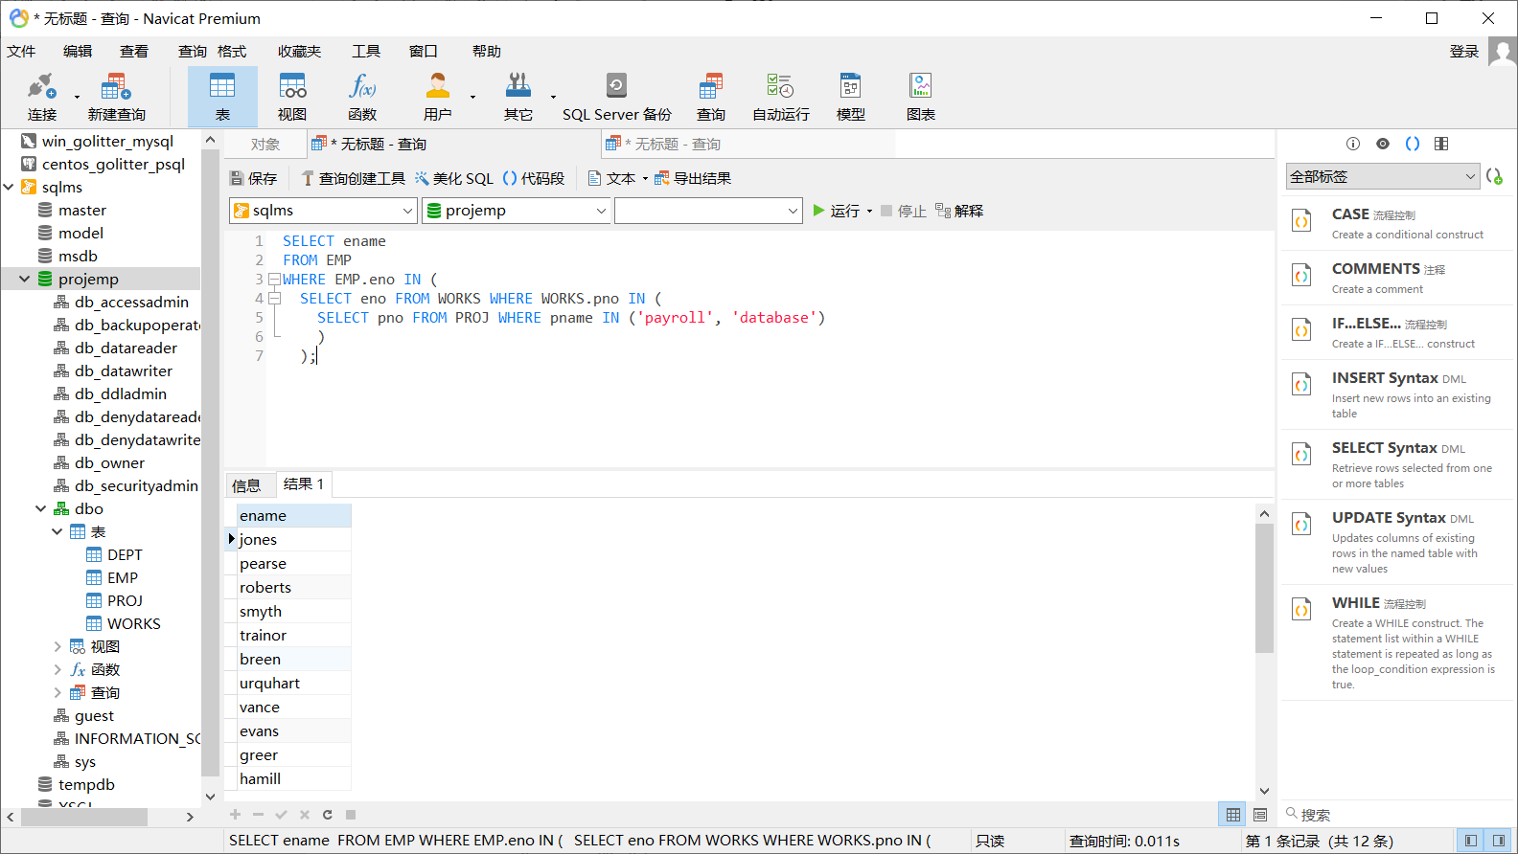

6)

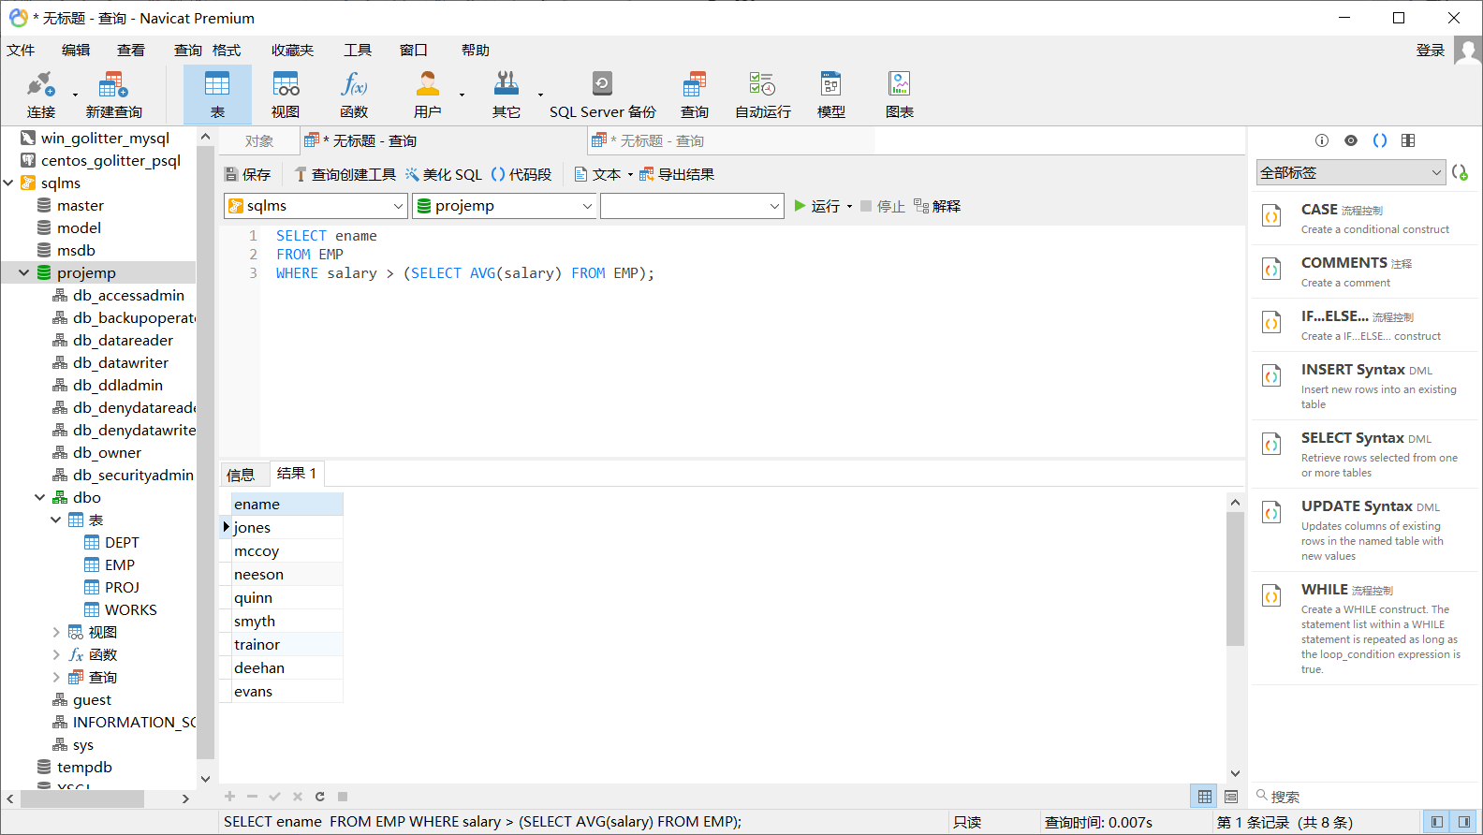

7)

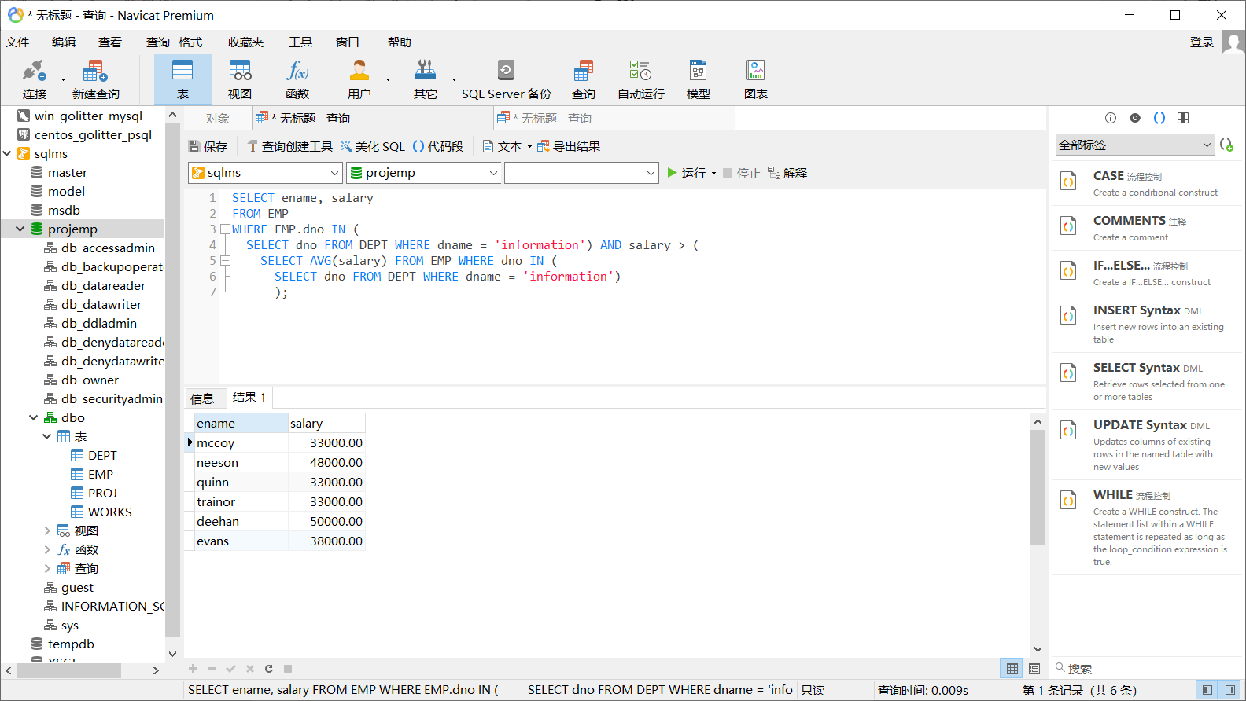

8)

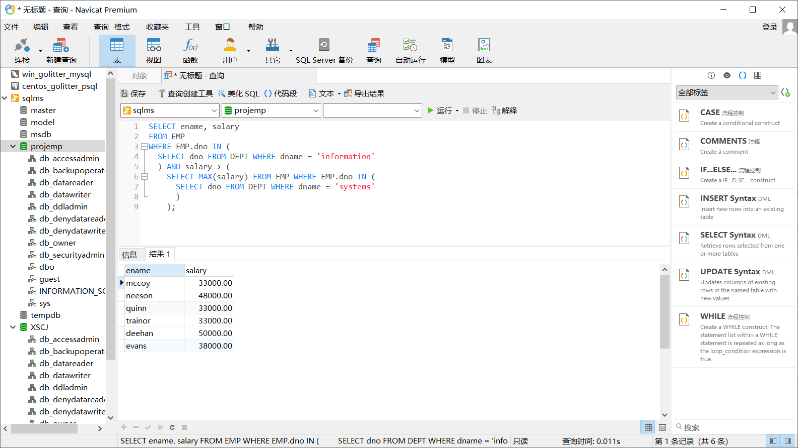

3.2 Debugging analysis

Problems during the debugging process and solutions

Give the program running screenshot

**5. Summary and experience**